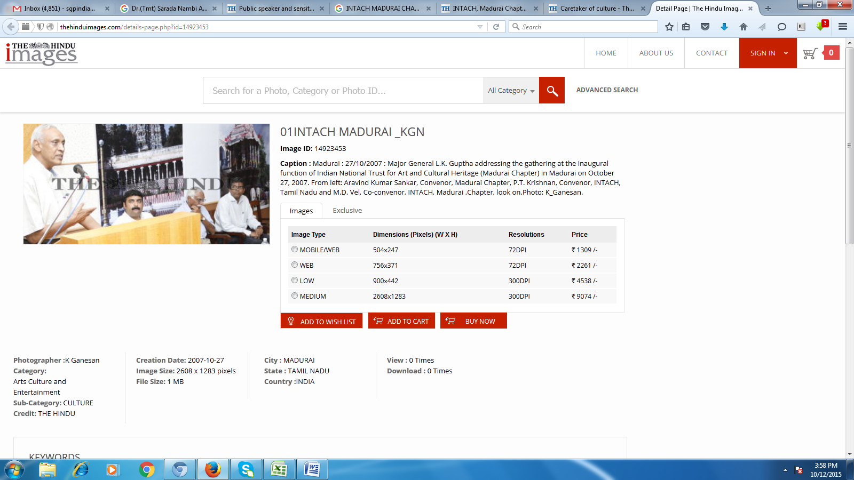

http://thehinduimages.com/details-page.php?id=14923453

01INTACH MADURAI _KGN
Image ID: 14923453
Caption : Madurai : 27/10/2007 : Major General L.K. Guptha addressing the gathering at the inaugural function of Indian National Trust for Art and Cultural Heritage (Madurai Chapter) in Madurai on October 27, 2007. From left: Aravind Kumar Sankar, Convenor, Madurai Chapter, P.T. Krishnan, Convenor, INTACH, Tamil Nadu and M.D. Vel, Co-convenor, INTACH, Madurai .Chapter, look on.Photo: K_Ganesan.

