Metroplus » Society
Published: September 25, 2014 19:16 IST | Updated: September 26, 2014 13:39 IST

Help the river run
SOMA BASU
- 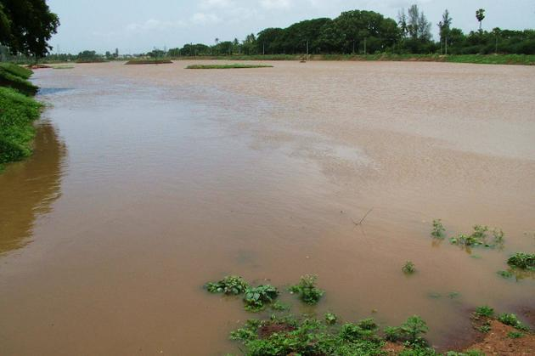
The Hindu
The Krishnampathy tank in Coimbatore. Photo:S. Siva Saravanan
- 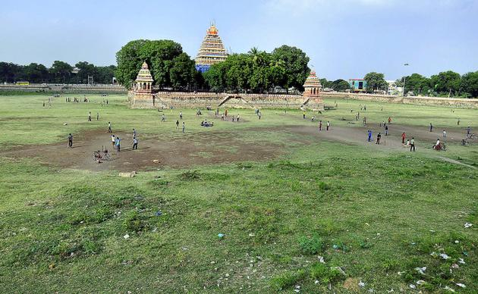
The Hindu
The Mariamman Teppakulam in Madurai. Photo: G. Moorthy
- 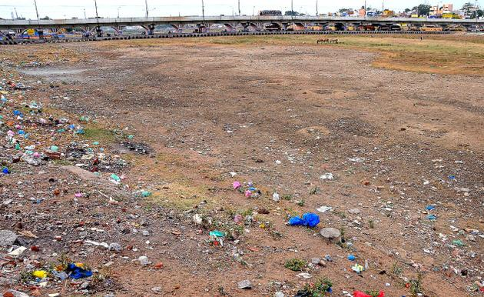
The Hindu
A view of dry Vaiga River in Madurai. Photo: S. James
- 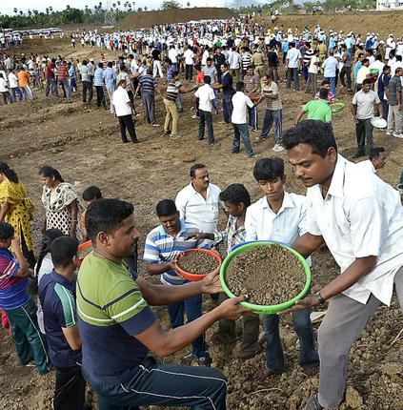
The Hindu
People help in desilting water bodies. Photo: K. Ananthan
- 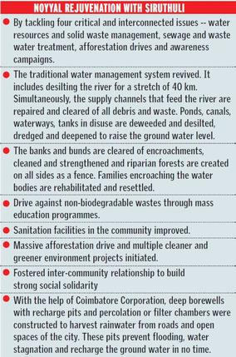

If Coimbatoreans can rejuvenate river Noyyal, can’t Maduraiites bring Vaigai river back to life?
For long enough the Vaigai river has been like a neglected wound across Madurai. Barely a decade ago Coimbatore’s lifeline, Noyyal too was in a similar state.
Like Vaigai today, Noyyal in 2003 resembled nothing more than a glorified sewage drain clogged with debris, chemical effluents, solid wastes and the city’s sewage. The monsoon rains had failed for three consecutive years and all the wells in the city were dry. The groundwater table depleted drastically and there was no water even at a depth of 1,000 feet. Long stretches of the river’s 40 km route crisscrossing the city was parched and people queued for miles for water.
Obviously, the river could not co-exist with the city’s explosive growth. Someone somewhere had to make a beginning and reverse the deplorable condition. Several committed corporate citizens and philanthropists did. They envisaged the river’s potential and thereby the city’s rebirth. They formed themselves into ‘Siruthuli’, an NGO, to work to rejuvenate the water resources in their city. Gradually eco-conscious citizens from all walks of life joined in to make it a massive peoples’ movement.
Today, most of the urban water bodies have been reclaimed. There is a substantial increase in the city’s water table and lush foliage blankets several areas, campuses and parts of the river bed. Together, the citizens of Coimbatore have rewritten the story of their water bodies.
A reimagining of the river’s place in modern Coimbatore is gaining traction, smiles Vanitha Mohan, the Managing Trustee of Siruthuli. Earlier, if Cauvery was in full spate the Noyyal too would flow vast, wide and deep. But over the years, rampant and illegal sand mining, encroachments, unchecked dumping of debris and waste pushed the river in her death throes. Once the river dried up, the network of tanks it fed also disappeared.
The beginning was not easy, says Vanitha. “When we started mapping the Noyyal river basin and were at sea figuring out how much work had to be done, we were criticised for being publicity hungry.”
Siruthuli knew the battle could be won only with peoples’ support. Awareness about environment’s fragile nature and the organisation’s objectives was generated. Given the air and water disconnect of the people, it took three years to garner public support for restoring the river and rejuvenating the nine tanks that garland the river. And when one lakh people walked in the Noyyal yatra, it signalled the time for change.
A major challenge was to channelize and desilt the waterways and the tanks and erect rainwater harvesting structures across the city to allow water to percolate down to the aquifers. To effectively manage waste was another hurdle. The use and throw complacency required a large scale awareness for people to shift to ‘reduce, reuse and recycle waste’.
Intensive door-to-door campaigns in six major municipal wards finally saw the citizens cooperating to convert the garbage into effective manure. “It took just 10 months and now very little waste goes to garbage dump yard,” says Vanitha.
With sustained efforts, the grey concretes were gradually changed into green covers by establishing happy tree zones, tree parks, and planting saplings following the Miyawaki method, a Japanese concept of urban forests where in 11 saplings can be grown together in a 3 by 3 feet pit.
Nurture Nature camps with children and adults, students and professionals became a regular weekly activity for reaching out and connecting with the people. It helped to turn around the distressing state of the city’s tanks. The first tank revived was Krishnampathy.
Periyakulam, the biggest lake spanning 325 acres, was cleared of its garbage, raw sewage and toxic waste. The water hyacinth that bred in dirty waters was harvested and converted into organic manure. With people lending a helping hand every Sunday, the landscape changed into a no-scrub ground.
“When 3,000 volunteers turned up the first Sunday of operation clean-up, all of us were smiling because we could sense people were taking up the ownership of their city,” says Vanitha. On the last day of cleaning before the monsoons, not less than 10,000 people poured onto the lake bed to clear the mess. Machines can do the same job faster and efficiently, but when people participate like this, it has a deeper satisfaction and meaning and success is guaranteed.
“Together we have made it happen,” says Vanitha. When people believe that they can change the world, things begin to happen and the change comes. “Now, if you fly over Coimbatore, you will see more greenery and water,” she smiles.
The Madurai chapter of INTACH had invited her and her colleague Sujani Balu to talk about their decade’s work that helped chart a course for Noyyal and once again nourish life across the city. Coimbatore now gets water at 25 to 60 feet. The Temple Town’s powers that be have perhaps made a beginning by understanding how it can be achieved.
When our rivers, tanks, lakes come alive people feel a sense of belonging because they have contributed to the revival. “This ownership,” believes Vanitha, “will also ensure that things do not turn messy again”.
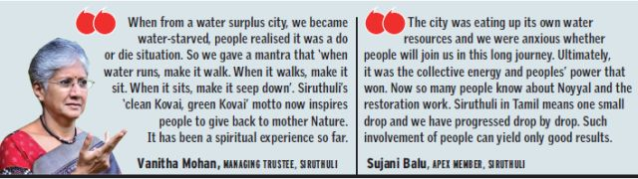
Keywords: Vaigai river, Noyyal river, Nurture Nature camps, Siruthuli, rivers conservation
- 50% off or more on popular movies
- Up to 60% off on branded Watches
Printable version | Feb 12, 2015 5:35:29 PM | http://www.thehindu.com/features/metroplus/society/help-the-river-run/article6446231.ece
© The Hindu

